**Introduction to MongoDB**

* MongoDB is an open source cross-platform document-oriented database. Classified as a NoSQL database, MongoDB uses JSON-like documents with optional schemas.
* As a document database, MongoDB makes it easy for developers to store structured or unstructured data. It uses a JSON-like format to store documents.
* But MongoDB actually stores data in BSON (Binary JavaScript Object Notation) format. It is a binary-encoded serialization of JSON documents. Using BSON we can make remote procedure calls in MongoDB. BSON data format supports various data-types like, String, Integer, Double, Boolean, null, Array, Object and Object Id.  
  For More Info: [*https://www.geeksforgeeks.org/datatypes-in-mongodb/*](https://www.geeksforgeeks.org/datatypes-in-mongodb/)
* In the context of MongoDB, "schemaless" refers to the flexible nature of the database that allows you to store and retrieve data without a predefined or rigid structure. Unlike traditional relational databases, where you define a fixed schema consisting of tables, columns, and relationships upfront, MongoDB allows you to store data without strictly enforcing a predefined schema.
* When you paste data in the functions always use close parenthesis after pasting the data into the function. If you use close parenthesis before pasting data in the function, then you will get an error.

**Database:-**In MongoDB, a database contains the collections of documents. One can create multiple databases on the MongoDB server.

Show Database Command:   
*show dbs*

As we freshly started MongoDB so we do not have a database except these three default databases, i.e, admin, config, and local.

Create Database Command:   
*use database_name*

This command actually switches you to the new database if the given name does not exist and if the given name exists, then it will switch you to the existing database. Now at this stage, if you use the show command to see the database list where you will find that your new database is not present in that database list because, in MongoDB, the database is actually created when you start entering data in that database.

**Note:**

* In MongoDB, the names of the database are case insensitive, but you must always remember that the database names cannot differ only by the case of the characters.
* A Database contains a collection, and a collection contains documents and the documents contain data, they are related to each other.
* Whenever we create a new document in the collection MongoDB automatically creates a unique object id for that document(if the document does not have it)

**Collection:-**

Collections are just like tables in relational databases, they also store data, but in the form of documents. A single database is allowed to store multiple collections.

Schemaless: As we know that MongoDB databases are schemaless. So, it is not necessary in a collection that the schema of one document is similar to another document. Or in other words, a single collection contains different types of documents like as shown in the below example where mystudentData collection contain two different types of documents:

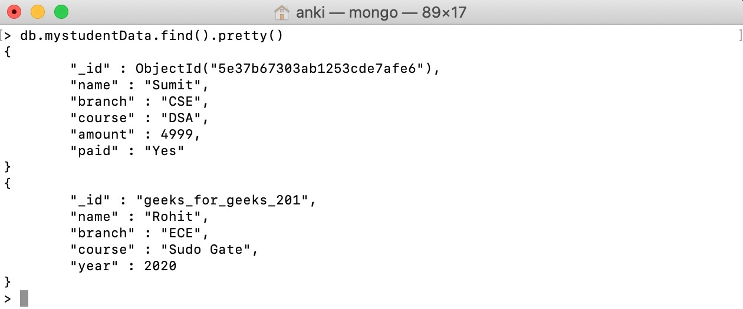

Naming Restrictions for Collection:

* Collection name must starts with an underscore or a character.
* Collection name does not contain $, empty string, null character and does not begin with system. prefix.
* The maximum length of the collection name is 120 bytes(including the database name, dot separator, and the collection name).

After creating database now we create a collection to store documents.

Create Collection Command:   
*db.collection_name.insertOne({..})*

Here, insertOne() function is used to store single data in the specified collection. And in the curly braces {} we store our data or in other words, it is a document.

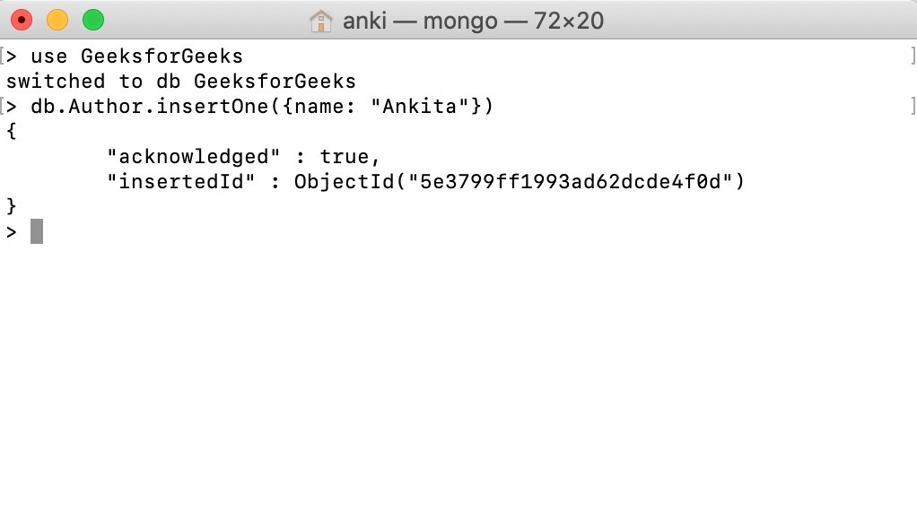

After creating collection we got a message(as shown in the above image) and this message tells us that the data enters successfully (i.e., “acknowledge”: true) and also assigns us an automatically created id. It is the special feature provided by MongoDB that every document provided a unique id and generally, this id is created automatically, but you are allowed to create your own id (must be unique).

**Document:-**

In MongoDB, the data records are stored as BSON documents. Here, BSON stands for binary representation of JSON documents, although **BSON contains more data types as compared to JSON**. The document is created using field-value pairs or key-value pairs and the value of the field can be of any BSON type.

Naming Restrictions for Collection:

* The field names are of strings.
* The _id field name is reserved to use as a primary key. And the value of this field must be unique, immutable, and can be of any type other than an array.
* The field name cannot contain null characters.
* The top-level field names should not start with a dollar sign ($).

The maximum size of the BSON document is 16MB. It ensures that the single document does not use too much amount of RAM or bandwidth(during transmission). If a document contains more data than the specified size, then MongoDB provides a GridFS API to store such type of documents.

**Important Notes:-**

* A single document may contain duplicate fields.
* MongoDB always saves the order of the fields in the documents except for the _id field (which always comes in the first place) and the renaming of fields may change the order of the fields in the documents.
* _id Field: In MongoDB, every document store in the collection must contain a unique _id field it is just like a primary key in a relational database. The value of the _id field can be set by the user or by the system (if the user does not create an _id field, then the system will automatically generate an ObjectId for _id field).
  + When you create a collection MongoDB automatically creates a unique index on the _id field.
  + The _id field is the first field of every document.
  + The value of the _id field can be of any BSON type except arrays.
  + The default value of the _id field is ObjectId.